Lab Rotation 1 Report
Title of the Project: Annotating the Haptic Greeting Corpus and Investigating Human Perceptions in Recognizing Haptic Greetings and Scenarios

Overview of the research project
Touch is one of the primary forms of human non-verbal communication. When greeting, people especially have various ways of exchanging emotions via touch (Van Erp & Toet, 2015; App et al., 2011; Field, 2010). In human-robot interactions, van Erp (2012) argued that adding mediated touch will reinforce the compatibility of human-like interaction between humans and robots, and also assist human partners in perceiving robots in a more positive way (Block et al., 2021). Despite the versatile functions of touch, this modality has only recently gained more attention in human-robot interactions.
To perform touch when greeting, social robots must automatically recognize and predict the potential of different haptic interactions in different social contexts. In this project, computer vision was chosen as the major method of predicting haptic interactions since computer vision with deep learning-based systems is particularly suited for learning complex patterns and predicting persons (Block et al., 2021). For that reason, the project's end goal is to use deep learning to develop social robots to perform socially meaningful haptic greetings. To this end, a haptic greetings corpus was developed, annotated and segmented (details about the corpus will be provided in the next section).
Within the scope of this Lab Rotation, we focused on annotating the videos that had an egocentric view to establish the human baseline for evaluating the models’ performance. To be more specific, the first goal of the project is annotating video materials in different phases of the interactions. The second goal of the project is to conduct a study investigating the capacity of humans to perceive scenarios and gestures from video. For this, we use a metric called prediction accuracy score as the human baseline for training models. The prediction accuracy score (expressed in a percentage) is a mathematical technique, which compares the predicted values to the actual values (Parashar, 2023). A higher percentage of prediction accuracy indicates a more accurate model (Schoone, n.d.). Based on this, the human baseline is an efficient metric to assess the performances of social robots.

The corpus
Corpus description
Previous studies concluded that specific touch gestures do not have universal meaning, but each gesture has varying precise meanings which depend on the contexts of the interactions (Jones & Yarbrough, 1985). Therefore, taking an exploratory approach, we combined 8 types of greetings (Handshake, High Five, Hug, Fist Bump, Shoulder Tap, Arm Touch, Elbow Bump, and Hold Hands) with 4 types of scenarios (Comforting, Supportive, Affectionate and Playful) in our corpus. By fully crossing types of greeting and scenario, we expected to cover all possible greeting-scenario interactions.
Later in this section, we will give more information about the procedure for building the corpus. However, this report will focus mainly on the second annotation and the perception study. In this project, we focus on annotating three different phases of the interactions: Start of Greeting, First physical contact, and End of Greeting. The Start of Greeting phase is defined as the first movement of the initiator to the first physical contact with the responder. This phase includes all body movements, facial expressions, all cues for the scenario, and upcoming touching gestures from the initiators. This initiating phase will be a major part of training the models to recognize and predict future actions. The First physical contact is determined by the moment when the greetings took place. In most cases, the designated gestures were performed visibly in the video frame at that moment. Lastly, the End of Greeting includes the greeting interactions between initiator and responder, and their movements when going back to their starting points.
The Haptic Greeting corpus consists of raw footage of the egocentric views (of both responders and initiators) and from the third point of view (exocentric views). It also includes the cut videos and the annotations of these cut videos. However, the cut videos and the annotations were only done on the videos with egocentric views of responders. In the second annotation, 1376 videos were derived from the raw footage of the responders’ views (21 dyads). Most of the videos are around 3-4 seconds. A few videos lasted 8 – 10 seconds. The corpus includes 8 types of social touch: handshake, hold hands, arm touch, hug, high-five, fist bump, elbow bump, and shoulder tap, and 4 types of scenarios; playfulness, comforting, affection, and supportiveness. For each dyad, that sums up to 64 combinations (participants in each dyad participated both as responder and as initiator), and 2 control scenarios, where participants did not do any touching actions (The control scenarios were not performed in Dyad 1 to Dyad 9). Some scenarios were done twice, either by accident, or due to participants wanting to redo the scenarios. In these cases, both recordings were annotated, since they might be analyzed with different purposes. When comparing two recordings of the same scenario-gesture interaction, it is clear that responders already knew the scenario and the type of greeting in the second recording. Therefore, the initiating time of these videos might be shorter and not show the dynamic nature of the interactions. However, since most of the first recordings are messier and more confusing, the second recordings help assess the behaviours of the participants when acting out the scenario.
Participants
42 participants took part in the construction of the corpus, 15 males and 27 females between 18 and 34 years old (33 of them are between 18 and 24 years old). The participants came from diverse cultural backgrounds: Turkey, India, Germany, Netherlands, Belgium, China, Poland, Croatia, Sweden, Romania, Bulgaria, Iran, Greece, Pakistan, Lithuania, Czech Republic and Slovenia. The interactions were recorded with two head-mounted Go-Pros providing a wide-angle egocentric view from the initiator's viewpoint and from the responder's viewpoint, who accordingly responded to the greetings. In addition, the interactions were recorded with a stationary camera that provided an exocentric perspective. The experimenter was in the room to give instructions (Schoone, n.d.)
After recording the interactions, the participants were asked several questions about their perceptions of common social touch greetings. Most of them agreed that they usually hug friends when saying goodbyes (25 participants agreed strongly) or greeting their family and friends (17 participants agreed strongly). However, there are mixed reactions to other types of social touch, for example, linking arms. Most of them do not like or do not usually link arms when walking with close friends (12 and 10 of respondents respectively disagree strongly). These reactions could be affected by cultural differences. In some cultures, haptic greetings are not very common. Therefore, people from these countries would feel more difficult or confused in expressing their emotions through haptic greetings.
Several remarks of the participants about the types of greetings and combinations of scenarios and greetings are worth mentioning. Most of them mentioned Elbow Bumps as the most unnatural and unclear type of greeting. That makes sense since this type of greeting was only communalized during the global pandemic time. Therefore, it tends to show respect for social distancing and/or obeying societal rules, rather than conveying social meaning or emotions. Hold Hands was also mentioned as one of the most unclear types of greeting. Some of them mentioned that there are different ways of expressing emotions through holding hands. Although their remarks will not be used directly as the data for this corpus study, they are insightful and should be considered when interpreting the results of the study.
Corpus compilation
Eight types of greeting gestures in our corpus were chosen based on the most common greetings people use in daily interactions, and four scenarios were chosen and formulated based on social robots’ various social roles (Schoone, n.d.). However, some gesture-scenario combinations are considered “weird” or “inappropriate” in social contexts. For example, comforting your friend who was just fired from their job by a high five seems to be not natural. Therefore, in the later study, I suggested to consider the validity of certain scenarios and exclude unnatural combinations.
The second annotation focused on the duration of the initiating actions, the varying timing of the touching behaviors, and the end of the greeting. Therefore, an annotation scheme was created. ELAN 6.5 was used to annotate the corpus. The annotation scheme includes one tier Responder with 3 types of vocabularies: start of greeting, first physical contact, and end of greeting (See Figure 1 for an example of the annotation file). A template Edit Controlled Vocabularies file .etf was created to reduce the amount of redundant work during the annotating process, and also to reduce the chance of making mistakes by the annotator.
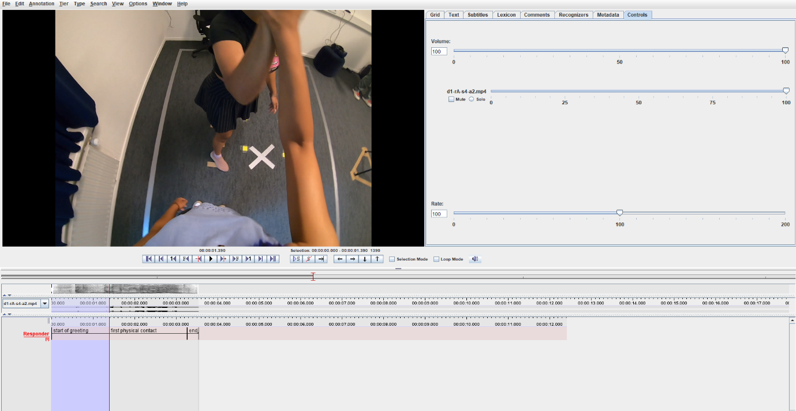
Figure 1: An example of the ELAN annotation file with one tier and three controlled
vocabularies. The frame was taken when the first physical contact took place.
From the raw footage, in which participants acted out the scenarios according to the instructions of experimenters, each interaction was cut from the moment the initiator started moving to the moment they came back to their first position. The videos were edited with Microsoft Clipchamp 2023, the default edit application on Windows laptops. All of the cut videos have 1920 x 1080 resolution, and the framerate is 30 FPS. As the participants are not professional actors andthe experiments did not want to interfere in their interactions, there are variations in the timing and starting positions of initiators. For example, sometime initiator did not start at the designated starting spot, or the initiator and responder started greetings at different moments (see Figures 2 and 3). Based on a case-by-case basis, the annotator decided to cut the videos as soon as the movements of the initiators were captured in the videos. However, not all movements of the initiators were captured in the videos, and the actual timings for the start of the greeting might not be represented correctly in some of the annotations.
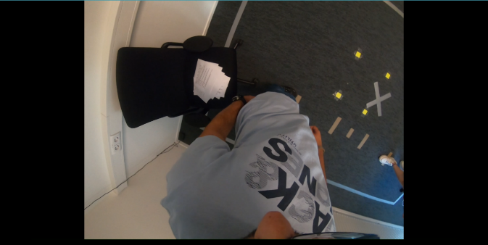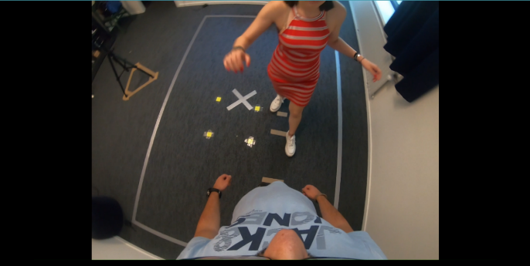
Figure 2: This example was taken from the same video. The start of the greeting (from egocentric view) was not captured correctly in the video because the initiator and the responder started the greeting at different times. When the initiator started moving (right), the responder was still reading the instructions(left).
Because of the limitation of the video angles, some movements of the participants were also not captured in the videos. For example, hug, arm touch, and shoulder tap are the most difficult ones to be captured from the egocentric view of responders. Therefore, the timings of the first physical contacts were decided by also using information from the audio channel. When there is a strong physical interaction, participants tend to make louder noises. The timing of the first interactions was estimated around the moment when there was a sharp change in the audio channel. However, to investigate the movements/behaviours of participants during the first physical contact, it is suggested to compare with the recordings from the egocentric views of the initiators and/or the exocentric views.

The Perception Study

The Research Questions
The first perception study using the Haptic Greetings Corpus showed that humans are capable of predicting the types of haptic greetings from video materials (both egocentric and exocentric views) (Schoone, n.d.). Specifically, the average accuracy score across 8 types of actions (in both egocentric and exocentric views) was 34%, this number is significantly higher than chance (Schoone, n.d.). The accuracy scores of participants for gesture recognition per gesture are also higher than chance (minimum accuracy = 15%). From these results, we further annotated the videos of egocentric views of responders according to different phases of the interactions (Start of Greeting, First physical contact, and End of Greeting) (see Section II. The Corpus for more details). The initiating phase (Start of Greeting) is especially important for humans and social robots to infer future actions (Block et al., 2021). In this perception study, three aspects of human perceptive capacity from the initiating phase of the greetings were investigated: the gestures, scenarios and duration.
First, the time needed for humans to correctly anticipate the type of action is important for understanding human perception. Although humans can relatively predict correctly future actions in terms of social touch, people have varying speeds of doing actions and other cues, which might affect the ability to recognize haptic greetings of responders. This study attempted to find how well people can predict accurately the types of actions at different gates: 50%, 75%, and 100%. Therefore, the first research question is How well do people predict accurately different types of gestures at different timeframe percentages? To answer this research question, the approaching phase of the interactions was cut into 3 arbitrarily chosen time frame percentages: 50%, 75%, and 100% (in the 100% timeframe, the first physical contact takes place).
The second aspect of human perception that we would like to investigate is whether humans can recognize the types of scenarios from the initiating phase of the greetings. Some researchers suggest that humans can recognize affections in human body movements (Atkinson et al., 2004) and the types of actions performed (Dittrich, 1993 as cited in Manera et al., 2011). Moreover, the ability to adapt to social touch initiated by humans is one of the essential elements that make human-robot interactions successful. Argall and Billard (2010) argued that social robots need to know and adapt to the correct type of interactions and the correct type of haptic affective information to perform meaningful interactions. To investigate this ability, in our corpus, four different types of scenarios were formulated with an emphasis on four distinctive sentiments (supportive, comforting, playful, and affectionate). The initiators were instructed to express these scenarios via their behaviors so that the responders could interpret and adapt their movements accordingly. Therefore, evaluating the ability of human participants to tell apart the types of scenarios in our video materials will be one of the focuses of this perception study. So, the second research question that we try to answer is: Can humans tell the differences between the 4 scenarios from the video material of the corpus?

Goals and Hypotheses
The goals of the perception study is to enrich the corpus with gesture recognition data and scenario and to provide human baselines. Firstly, we want to investigate the ability to perceive gestures at different duration percentages. Suggesting that at the shorter duration, people can still recognize gestures as well as at longer durations, we pose two hypotheses:
(H1) The prediction accuracy score of the type of gesture at longer duration is higher than the prediction score at shorter durations (accuracy score at 100% > accuracy score at 75% > accuracy score at 50%)
(H2) The prediction scores at 100%, 75%, and 50% duration are all higher than chance level (the prediction accuracy scores are all higher than 12.5%).
The second goal of the perception test is to test whether the accuracy scores of all scenarios are higher than chance. The results from this perception test can help to inform whether humans can tell the difference between the four types of scenarios. Therefore, the third hypothesis is that:
(H3) The accuracy prediction scores for 4 types of scenarios are higher than chance (25%)
In addition, we would like to see if the differences in expressions of the performers affect the accuracy scores of the perceiver. Suggesting that the performances of people with exaggerated, clear movements will lead to higher scores, and vice versa. Our fourth hypothesis is that:
(H4) Performers with exaggerated movements (Dyad 1) will get higher perception accuracy scores than performers with less exaggerated movements (Dyad 10)
The rationale for choosing stimuli (Dyad 1 and Dyad 10) will be explained in the method and material section.

Methodology
Materials
The egocentric views of responders from two dyads (Dyad 1 and Dyad 10) of the corpus were selected as the stimuli for the perception study. The experimenter chose these two dyads based on the visibility of facial expressions in the videos and the general exaggeration in the movements of participants. Both participants in Dyad 1 frequently had exaggerated movements and highly expressive facial expressions. They were both good at interpreting and acting out scenarios. Dyad 10 was chosen because they were good at interpreting the scenarios, but they had less exaggerated movements compared to participants in Dyad 1.
64 videos from Dyad 1 and Dyad 10 were cut at 50%, 75%, and 100% from the Start of Greeting. Therefore, in total, 2 (dyads) x 3 (durations) x 4 (scenarios) x 8 (gestures) x 2 (trials) = 384 videos (divided randomly into 12 distinct groups of 32 videos) were used as stimuli in the perception study (see Perception Study – Matched videos and answers.xlsx for the 12 lists of videos). Each participant was assigned randomly to watch one group of videos (32 videos).
The procedure of the perception study
The study took place online through a survey-format study in Qualtrics. Participants were first introduced to the main objectives of the study. If they did not take part in either the corpus study or the first perception study, they were then asked to sign the consent form and continue with the study. Four scenarios and eight gestures were introduced with examples. Practice questions were provided to make sure that participants were familiar with the task. After the practice questions, each participant was randomly assigned to watch a sequence of videos. After watching each video, they were suggested to rewatch the video two more times and then asked to indicate what kind of greeting and scenario they could perceive from the movements in the video.

Data Processing and Analysis
Data Preprocessing
To answer the research questions, multiple analyses have been performed. To investigate the overall recognition ability and also the effect of time, average accuracy scores for scenarios and gestures were taken across all time frames and on each level timeframe. Preprocessing data was done to clean and format datasets that are suitable for both gaining average accuracy scores and also for creating confusion matrices and classification reports. The preprocessing was done mostly in Excel and SPSS, and analyzing data was done on SPSS and Python.
Data preprocessing and analysis for calculating average accuracy scores includes several steps. First, the Excel dataset from Qualtrics was cleaned to contain only prediction values with the correct matching group of videos. Next, the cleaned dataset was then recoded to numerical values to gain mean accuracy scores, which was done on SPSS. To generate confusion matrices and classification reports, the tables containing the ground-truth values and prediction values were generated and were then imported into Python for analysis.
After getting average accuracy scores of gestures and scenarios (for each time frame and across all timeframes), several t-tests and Factorial ANOVA analyses were performed. To test the effect of gesture, duration, and the interaction effect of duration on gestures, one eight (gestures)-by-three (durations) Factorial ANOVA was conducted. Similarly, one four (scenarios)-by-three (durations) Factorial ANOVA was performed to investigate the effect of scenario, duration, and the interaction effect of duration on scenario. Next, to test whether people’s prediction accuracy scores were higher than chances, several one-sample t-tests were conducted. Lastly, eight confusion matrices and classification reports were generated to investigate if participants could systematically predict the types of gestures and scenarios. The confusion matrices are also helpful in understanding if there are confusion patterns in our corpus. Especially, in this study where the proportion of conditions was not equally distributed, the F1 scores from the classification reports might be more meaningful than the accuracy scores.
Results
H1: The prediction accuracy scores of gestures at a higher timeframe rate are higher than the prediction scores at a lower timeframe rate (accuracy score at 100% > accuracy score at 75% > accuracy score 50%)
To test if people predict gestures better when the time for information is longer (H1), an eight-by-three Factorial ANOVA was performed: three durations (50%, 75%, and 100%) and eight types of gestures (Handshake, High Five, Hug, Fist Bump, Shoulder Tap, Arm Touch, Elbow Bump and Hold Hands). Several conditions showed deviations from normality (e.g., z-score skewness and kurtosis for hug at 75% durations are -4.84 and 7.07 respectively). The assumption of homogeneity of variances was not met. The VR is 84.5. The analysis was bootstrapped to guarantee the robustness of the results.
Factorial ANOVA showed a significant main effect of duration, F(2, 360) = 37.92, p < .001, η²_{partial} = .174, representing a large effect size. The average accuracy score for 50% duration was the lowest (M =.46, SD = .42); the accuracy score for 75% duration was higher (M=.74, SD = .37), and the accuracy score for 100% duration was highest (M=.79, SD = .32). There was also a significant main effect of gestures, F(7, 360) = 16.20, p <.001, a large effect size (η²_{partial} = .24). (see Table 2 for the overall accuracy scores between all gestures-and-time conditions). Hugs are predicted with the highest accuracy (M = .92, SD = .22), and Shoulder Tap is the most difficult gesture for people to predict (M= .37, SD = .38). Finally, there was also a significant interaction effect between time and gestures, F (14, 36) = .24, p =.001, η²_{partial} = .08 showing that….
To further investigate which levels and gestures are significantly different from each other, post-hoc Turkey-HSD analyses on both duration and gestures were performed. The post-hoc analysis of duration showed that the average accuracy score at 50% was significantly lower than those of the other two timeframe rates, but the average accuracy score at 75% was not significantly lower than that of 100%. From the post-hoc analysis of the
Timeframe Levels | Gestures | Accuracy Score
50% | Hand Shake | 82%( M=.82, SD =.29)
 | High Five | 31%( M=.31, SD =.38)
 | Hug | 83%( M=.83, SD=.34)
 | Fist Bump | 72%( M=.72, SD=.37)
 | Shoulder Tap | 13%( M=.13, SD= .25)
 | Arm Touch | 21%( M=.21, SD=.26)
 | Elbow Bump | 40%( M=.40, SD =.40)
 | Hold Hands | 30%( M=.30, SD =.31)
75% | Hand Shake | 80%( M=.80, SD=.43)
 | High Five | 76%( M=.76, SD=.37)
 | Hug | 94%( M=.94, SD=.14)
 | Fist Bump | 85%( M=.85, SD=.34)
 | Shoulder Tap | 46%( M=.46, SD=.40)
 | Arm Touch | 61%( M=.61, SD=.37)
 | Elbow Bump | 82%( M=.82, SD= .29)
 | Hold Hands | 65%( M=.65, SD=.41)
100% | Hand Shake | 68%( M=.68, SD=.38)
 | High Five | 84%( M=.84, SD= .26)
 | Hug | 99%( M=.99, SD=.05)
 | Fist Bump | 97%( M=.97, SD= .09)
 | Shoulder Tap | 51%( M=.51, SD= .38)
 | Arm Touch | 60%( M=.60, SD= .29)
 | Elbow Bump | 86%( M=.86, SD=.28)
 | Hold Hands | 84%( M=.84, SD=.29)
Total | Hand Shake | 77%( M=.77, SD=.34)
 | High Five | 63%( M=.63, SD=.41)
 | Hug | 92%( M=.92, SD=.22)
 | Fist Bump | 85%( M=.85, SD=.31)
 | Shoulder Tap | 37%( M=.37, SD= .38)
 | Arm Touch | 47%( M=.47, SD= .36)
 | Elbow Bump | 69%( M=.69, SD= .39)
 | Hold Hands | 60%( M=.60, SD=.41)
gesture factor, it was revealed that each gesture is significantly different from several other gestures but not all. The Confusion Matrices might be more insightful to see which gestures are being more confused with each other.
Investigating the interaction effect between gestures and duration, the accuracy scores of 5 out of 8 gestures (High Five, Shoulder Tap, Arm Touch, Elbow Bump, and Hold Hands) are significantly different across 3 timeframe levels. However, the accuracy scores are only significantly different between 50% and 100% timeframe levels, and between 50% and 75% timeframe levels, but not significantly different 75% and 100% timeframe levels. The other three gestures (Hug, Handshake, and Fist Bump) got the highest accuracy scores and the differences between the three-time levels are not significant. Especially, Handshake is the only gesture with descending accuracy scores despite the increasing timeframe rates. However, the interaction effect between time and gesture of Hand Shake was not significant, F(2, 36) = .83, p=.44.
The results from these interaction effects showed a ceiling effect of duration on predicting gestures. That means that people got better at recognizing and predicting gestures when they were given more time, but only to a certain level. When they reached the threshold, even when given more time, humans could not predict gestures better. However, depending on the gestures, their performances varied. For example, participants were good at recognizing Hug, Hand Shake, and Fist Bump even when there was less information. People also improved at perceiving the High Five, Shoulder Tap, Arm Touch, Elbow Bump, and Hold Hands when they were given more time, but also could not get a better accuracy score after a 75% timeframe rate.
Table 2: Overview of Accuracy Scores of Gestures x Time

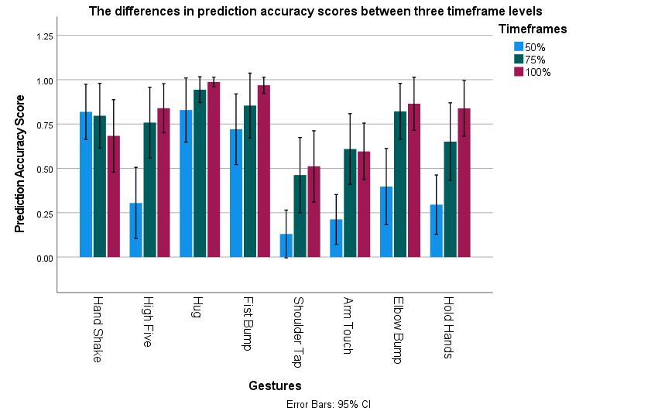
Figure 4: Bar Graph for accuracy scores of 8 types of gestures across 3 durations. Accuracy Scores for Hug, Handshake, and Fist Bump are not significantly different across 3 durations.
Confusion Matrices and Classification Reports
To better understand the perception of people on different types of gestures, four confusion matrices (one for overall conditions, three for each duration) with the corresponding classification reports were generated. In all four confusion matrices( see Figures 2 and 3), there are clear dark diagonal lines, which indicate the number of instances where participants correctly predicted gestures (the darker the line is, the more accurately the participants predicted gestures). Hug had the highest number of correct predictions in all confusion matrices, which also shows in the almost perfect accuracy scores for Hug (M =.92, SD=.22). In all confusion matrices, Arm Touch and Shoulder Tap had the lowest number of correct instances, they tended to be confused with each other. At the 50% duration level, Arm Touch and Shoulder Tap got the lowest recognition and were confused with other gestures (e.g. the number of cases people mistook Handshake for Arm Touch and Shoulder Tap was even higher than the correct instances). Accuracy got higher when the time increased, which means that participants predicted Arm Touch and Shoulder Tap more accurately when receiving more information.
From the classification reports (see Appendix A), we could see an overall accuracy score of 66% across all duration levels. This is the human baseline for predicting gestures. The accuracy scores for each duration were also generated. Since this is an imbalanced-class dataset, F1 scores might be more meaningful than the accuracy scores. Following similar patterns in the confusion matrices, Arm Touch and Shoulder Tap are the two gestures getting the lowest scores in all levels. Especially at the 50% timeframe level, there is a huge difference between these two types of gestures and other types of gestures (see Table 4 in Appendix A). Despite getting high scores at other levels, F1-scores for High Five and Hold Hands at 50% level were much lower than other gestures (0.37 and 0.38 respectively). That could be explained by the low Recall scores of these gestures. This substantial difference could hint that people have more difficulty in predicting the High Five and Hold Hands when there is less information. However, this conclusion should be tested in future research.

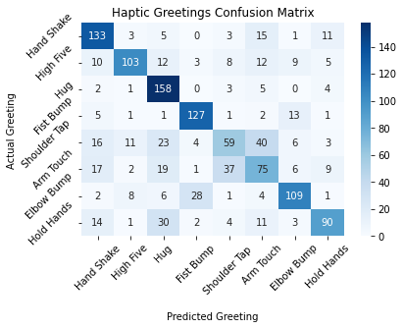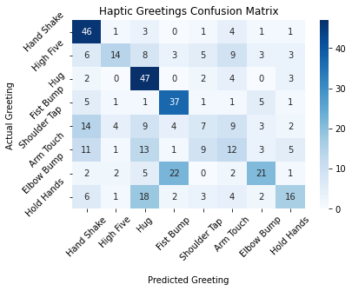
Figure 5: Confusion Matrices for Gestures at all timeframe levels (left) and at 50% timeframes (right)
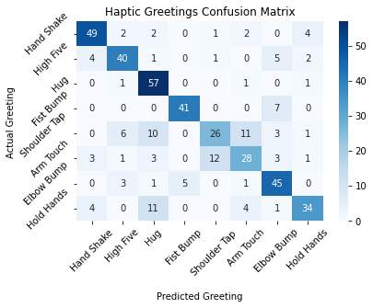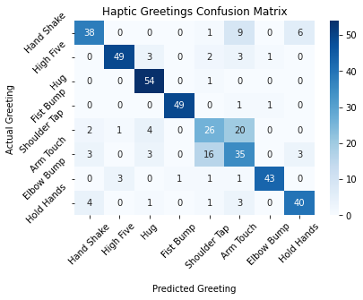
Figure 6: Confusion Matrix for Gestures at 75% timeframe level(left) and at 100% timeframe level(right)
(H2) The prediction scores at 100%, 75%, and 50% levels are all higher than chance (the prediction accuracy scores are significantly higher than 12.5%).
To test if people’s capacity to predict gestures is better than chance (12.5%), three one-sample t-test analyses were performed on their average accuracy scores. Several additional t-tests were done on the High Five, Shoulder Tap, Arm Touch, and Hold Hands at a 50% timeframe level. Since they are the four conditions with the lowest accuracy scores, the four additional analyses were performed to investigate if the accuracy score of individual gestures was also higher than chance. All variables were not normally distributed (e.g., at 100% timeframe level, z-score skewness = -6.87, z-score kurtosis = 2.6). Therefore, the p-values may not be reliable, and all three analyses were bootstrapped at 95% confidence interval. On average, the prediction accuracy scores of all three timeframe levels were higher than chance (.125). These differences were significant (see Table 7). However, the accuracy scores for High Five Shoulder Tap and Arm Touch at 50% timeframe level were not significantly higher than chance (see Table 8).
The results of these t-tests together with the results from the Factorial ANOVA show that people can predict gestures even at low time frames such as 50%. However, some gestures such as High Five, Shoulder Tap, and Arm Touch are more difficult for people to predict at lower timeframe rates. Moreover, the insignificant difference between 75% and 100% timeframe rates shows that there is a ceiling effect of time on predicting gestures. In other words, people do not need the whole initiating phase to recognize the gesture that the initiator is going to do next. They become better at predicting gestures when given more time, but reach a threshold after which this effect stops, and they could not get better at predicting gestures.
Table 3: Overview of the differences between accuracy scores of gestures at three timeframe levels and chance.
Timeframe Levels | Accuracy Scores | Difference between Prediction and Chance
50% | 46%(M=.46, SD=.42) | M_{diff} = .34, t(127) = 9.2, p<.001, 95% CI [0.27, 0.41], d = .813
75% | 74%(M=.74, SD=.36) | M_{diff} = .61, t(127) = 18.9, p<.001, 95% CI [0.54, 0.67], d = 1.68
100% | 79%(M=.79, SD=.32) | M_{diff} = .66, t(127) = 23.7, p<.001, 95% CI [0.61, 0.71], d= 2.1

Table 4: Overview of differences between four conditions with the lowest accuracy scores and chance. Only Hold Hands is significantly different at 0.05 level.
Conditions | Accuracy Scores | Difference between Prediction and Chance
High Five at 50% timeframes | 31%(M =.31, SD = .38) | M_{diff} = .18, t(15) = 1.91, p = .075, 95% CI [0.003, 0.36], d = .48
Shoulder Tap at 50% timeframes | 13%(M =.13, SD= .25) | M_{diff} = .005, t(15) = .082, p = .94, 95% CI [-0.104, 0.156], d =.021
Arm Touch at 50% timeframes | 21%(M =.21, SD = .26) | M_{diff} = .088, t(15)=1.33, p = .203, 95% CI[-0.029, 0.22], d = .33
Hold Hands at 50% timeframes | 29%(M =.29, SD = .31) | M_{diff} = .17, t(15) = 2.18, p =.046, 95% CI[0.03, 0.32], d =.55

(H3) The accuracy prediction score for 4 types of scenarios is higher than chance (25%)
To test if people predict scenarios better when the duration for information is longer, a three-by-four Factorial ANOVA was performed with three durations (50%, 75%, and 100%) and four types of scenarios (Affectionate, Playful, Comforting, and Supportive). Several conditions showed deviations when assessing the normality assumption (z-score skewness and z-score kurtosis for Affectionate at 50% duration are 4.14 and 2.64 respectively). The assumption of homogeneity of variances was not met. The VR is 4.06. The analysis was bootstrapped to guarantee the robustness of the results.
The Factorial ANOVA showed no significant main effect of duration, F(2, 37) = 1.78, p =.17, η²_{partial} = .01. However, there was a significant main effect of scenario, F(3, 372) = 7.9, p <.001, η²_{partial} = .06. (see Table 5 for the accuracy scores of predicting four scenarios). Comforting gets the highest accuracy score (M = .35, SD = .33), and, Affectionate is the most difficult scenario for people to predict (M= .17, SD = .25). Finally, there was no significant interaction effect between time and scenarios, F(6, 37) = .81, p =.57, η²_{partial} = .01. The results from the Factorial ANOVA show that people do not predict scenarios better when they are given more time. However, across different scenarios and contexts, people might be able to tell the difference.
To further investigate if people can accurately tell the differences between four types of scenarios, we performed five one-sample t-tests on the chance level (25%). All variables were not normally distributed (e.g., z-score skewness and z-score kurtosis of Affectionate score were -2.06 and 2.94 respectively). Therefore, the p-values may not be reliable, and all analyses were bootstrapped at a 95% confidence interval. On average, the overall prediction accuracy score (M =.26, SD = .29) was not significantly higher than chance (25%) (M_{diff} = .012, t(38) = .83, p = .42 95% CI [-0.02, 0.04], d = .04). Similarly, Supportive and Affectionate were not significantly higher than chance (see Table 5 for details). However, the accuracy scores for Playful and Comforting are significantly higher than chance. The Confusion Matrices and Classification Report might be more insightful into which scenario is being more confused with each other. Overall, we can conclude that people are not good at distinguishing and recognizing a scenario.
Table 5: Overview of Scenario Accuracy Scores and the difference between prediction accuracy score and chance
Scenarios | Accuracy Scores | Difference between Prediction and chance level (25%)
Affectionate | 17%( M = .17, SD = .25) | M_{diff} = -.08, t(95) = -3.04, p = .01 95% CI [-0.13, -0.03], d = -.31
Playful | 31%( M = .31, SD = .32) | M_{diff} = .06, t(95) = 1.9, p = .06 95% CI [0.00073, 0.13], d = .2
Comforting | 35%( M = .35, SD = .33) | M_{diff} = .097, t(95) = 2.91, p =.01 95% CI [0.03, 0.16], d = .29
Supportive | 22%( M = .22, SD = .24) | M_{diff} = -.03, t(95) = -1.33, p =.19 95% CI [-0.07, 0.02], d = -.14
Overall | 26%( M = .26, SD = .29) | M_{diff} = .01, t(38) = .83, p = .42 95% CI [-0.02, 0,04], d = .042

Confusion Matrices and Classification Report
Although there is a significant effect of recognizing scenarios, there are no dark diagonal lines in all 4 Confusion Matrices. That provides us information that people had a lot of difficulty in distinguishing scenarios. Playful is the type of scenario that is predicted in most cases but the accuracy scores for Playful were not higher than other scenarios. Meanwhile, Comforting consistently got the highest accuracy scores in all timeframe levels (F1-scores of Comforting were around 0.35-0.41, see Appendix B). That is consistent with the results from the t-test analysis that the accuracy of the Comforting scenario is significantly higher than chance. (See tables Table 5 to see the overall results).

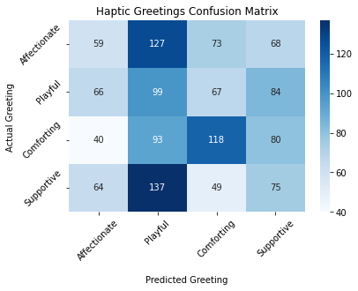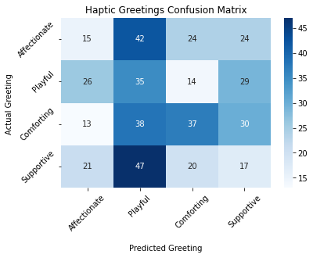
Figure 7: Confusion Matrix for Scenarios at 50% duration (right) and for all duration level(left)
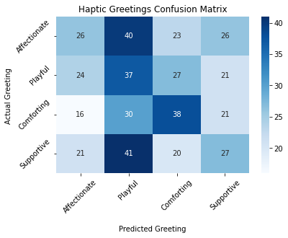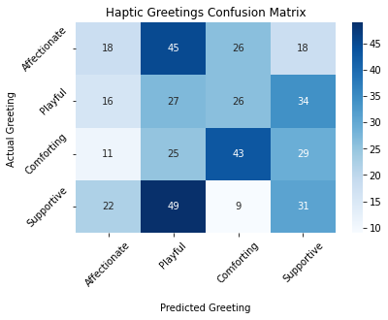
Figure 8: Confusion Matrix for Scenarios at 75% duration (left) and at 100% duration (right)
The results from the analyses only partly support the hypothesis (H3) that the accuracy prediction scores for 4 types of scenarios are higher than chance (25%). From the analyses, we found that people can tell that there are differences in scenarios based on the information (gestures, facial expressions, movements, etc.) in the video materials. However, they had difficulty in telling exactly what scenarios were performed in the videos. The difficulty varied from scenario to scenario as it was shown that people are good at recognizing Comforting scenarios but very bad at recognizing Affectionate scenarios, for example. In terms of time, people do not recognize scenarios better when the information is longer. That means that even when the greetings are already performed, they cannot recognize the scenarios better than when the initiators just started moving.
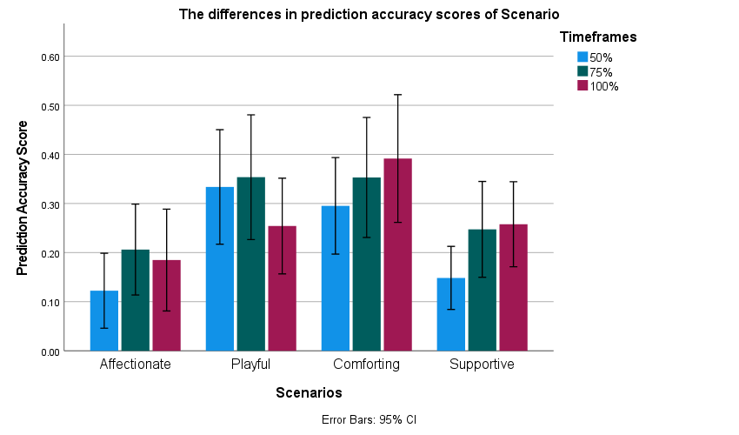
Figure 9: Bar Graph for accuracy scores of scenarios across 3 durations. Only the accuracy scores of Playful and Comforting are significantly higher than the chance
(H4) Performers with exaggerated movements (Dyad 1) will get higher recognition accuracy scores than performers with less exaggerated movements (Dyad 10)
Finally, the kind of movement in the video materials were added as an additional variable . Participants in Dyad 1 have more exaggerated movements compared with participants in Dyad 10. To test the recognition accuracy scores of two dyads, two independent t-tests were performed.
To test the differences in gesture recognition scores between Dyad 1 and Dyad 10, an independent t-test was performed. The variables were not normally distributed (e.g., z-score skewness and z-score kurtosis for Dyad 1 were -2.29 and 4.12). An equal variance between the two groups was assumed (VR ratio = 1.18). Therefore, we performed bootstrap to ensure the robustness of the result. On average, people perceive gestures better in dyad 10 (M =.73, SD = .37) than in Dyad 1 (M= .59, SD = .40). This difference is significant (M_{diff} = -.14, p<.001, 95% CI = [-0.21, -0.06], d = -.36.
To test the differences in scenario prediction scores between Dyad 1 and Dyad 10, an independent t-test was performed. The variables were not normally distributed (e.g., z-score skewness and z-score kurtosis for Dyad 1 were 5.05 and 0.73). An equal variance between the two groups was assumed (VR ratio = 1.29). Therefore, we performed bootstrapping to ensure the robustness of the test. On average, people perceive scenarios better in Dyad 1 (M =.27, SD = .31) than in Dyad 10 (M = .25, SD = .27). However, this difference is not significant (M_{diff} = .02, p =.41, 95% CI = [-0.03, 0.08]), d =.08.
The results from two t-test analyses only partly show support for our hypothesis. To be more specific, they provided evidence that when predicting gestures, exaggerated movements might not be needed for people to recognize. Even with less exaggerated movements, people can still perceive gestures better than when provided with fewer movements. For scenarios, exaggerated movements might be needed since with more exaggerated movements people can predict scenarios more accurately. However, from the analysis, the higher accuracy score for predicting scenarios with more exaggerated movements was not significant. Therefore, in future research where there are more materials and time, researchers could investigate this phenomenon with careful and detailed materials on different dyads.
Discussion: Interpretation
Findings
Overall, the current study aims to explore the capabilities of humans when predicting different types of haptic greeting gestures from video materials. In real life, humans' perception of haptic greetings uses information such as types of gestures, contexts of the greetings, non-verbal cues, duration, and so on. Therefore, this perception study does not only attempt to investigate the overall differences between gestures but also tries to break down this information to dive deeper into understanding the abilities of humans’ perception. To do that, firstly, the study investigated the human ability to predict gestures at different durations of the initiating phase. Secondly, it also tried to investigate whether people can tell the differences in scenarios of haptic greeting situations. Lastly, the study also attempted to understand whether people can perceive scenarios and predict gestures better when seeing more exaggerated movements. In the end, the perception accuracy scores from the study will be used as the human baselines for training deep-learning models with the ability to predict haptic greetings.
The Haptic Greetings Corpus, which was built by combining diverse social situations and several common haptic greeting gestures, was used as the stimuli of the perception study. From the videos of the corpus, participants had to predict gestures and scenarios, and their perception accuracy scores were then used for the analysis. Overall, the mean accuracy score for predicting gestures was 66%. The accuracy scores increased from 46% to 73% to 78% along with the increase of durations (These accuracy scores will be used as the corresponding human baselines for training the deep-learning models). The differences amongst these accuracy scores were only significant between 50% and 75%, 50% and 100% levels, but not significant between 75% and 100% levels, indicating a ceiling effect of duration on predicting gestures. The accuracy scores at different durations were also significantly higher than when they randomly predicted gestures. These results show support for our (H1) and (H2). Therefore, we concluded that people do not need the whole initiating phase to predict gestures and that people can predict gestures even at low time frames such as 50%. Another finding is that humans improved at recognizing and predicting gestures when they were given more time, but only to a certain level. When they reach a certain threshold, being given more time would not help them predict haptic greeting gestures better.
Previous research by Jung et al. (2017) suggested that differences between individuals and gesture confusion contribute to the difficulty in accurately classifying gestures. Similarly, in this study, it was found that there were variations in participants’ accuracy scores amongst eight types of gestures. Results from the confusion matrices and the classification reports showed that participants could predict some gestures quite well even when there is less information, for example, Hug, Hand Shake, and Fist Bump. Meanwhile, it was also found that some gestures such as Shoulder Tap, Arm Touch are the most difficult for people to predict. Hold Hands and High Five are more difficult for people to predict at lower timeframe rates, but, the capacity to predict these gestures improves quickly when there is more information.
In terms of recognizing scenarios, the mean accuracy score is 26%. However, the accuracy scores for each scenario vary: Affectionate (17%), Playful (31%), Comforting (35%) and Supportive (22%). Different from gestures, participants do not predict scenarios better when given more time. That means that even when the greetings are already performed, they cannot recognize the scenarios better than when the initiators just started moving. Testing the accuracy scores of predicting scenarios shows that participant could tell the differences amongst scenarios, but their overall accuracy score (26%) is not higher than chance. Participants could only recognize Playful and Comforting better than chance. These results partly support for (H3). Therefore, further research could be conducted to find the differences between the four scenarios. The confusion matrices and classification reports of recognizing scenarios at different timeframe rates show that Playful is the scenario that most people predicted. However, it is not the scenario with the highest accuracy scores but Comforting. In all durations, Comforting consistently got the most correct predictions. The results from prediction accuracy scores of scenarios do show that recognizing scenarios from video materials is still a challenge for human. However, in certain cases such as in Comforting, the scenario is clearer. In the future, new studies should be done to investigate how and why participants could recognize Comforting more accurately than in other scenarios and which other social scenarios can be recognized.
Finally, this study also aims to investigate the factor of exaggerated movements in predicting haptic greeting gestures. From the analysis, it was found out that exaggerated movements might not be needed for predicting gestures since participants can predict gestures relatively accurately when seeing less exaggerated movements. Meanwhile, the analysis shows that seeing more exaggerated movements helps participants to recognize scenarios better. However, this effect was not significant. Therefore, in future research researchers could investigate this phenomenon with other stimuli with different levels of exaggerated movements.

References
App, B., McIntosh, D. N., Reed, C. L., & Hertenstein, M. J. (2011). Nonverbal channel use in communication of emotion: How may depend on why. Emotion, 11(3), 603–617. https://doi.org/10.1037/a0023164
Atkinson, A. P., Dittrich, W. H., Gemmell, A. J., & Young, A. W. (2004). Emotion Perception from Dynamic and Static Body Expressions in Point-Light and Full-Light Displays. Perception, 33(6), 717–746. https://doi.org/10.1068/p5096
Block, A. E., Christen, S., Gassert, R., Hilliges, O., & Kuchenbecker, K. J. (2021). The Six Hug Commandments: Design and Evaluation of a Human-Sized Hugging Robot with Visual and Haptic Perception. Proceedings of the 2021 ACM/IEEE International Conference on Human-Robot Interaction, 380–388. https://doi.org/10.1145/3434073.3444656
Field, T. (2010). Touch for socioemotional and physical well-being: A review. Developmental Review, 30(4), 367–383. https://doi.org/10.1016/j.dr.2011.01.001
Jones, S. E., & Yarbrough, A. E. (1985). A naturalistic study of the meanings of touch. Communication Monographs, 52(1), 19–56. https://doi.org/10.1080/03637758509376094
Jung, M. M., Poel, M., Poppe, R., & Heylen, D. K. J. (2017). Automatic recognition of touch gestures in the corpus of social touch. Journal on Multimodal User Interfaces, 11(1), 81–96. https://doi.org/10.1007/s12193-016-0232-9
Manera, V., Becchio, C., Cavallo, A., Sartori, L., & Castiello, U. (2011). Cooperation or competition? Discriminating between social intentions by observing prehensile movements. Experimental Brain Research, 211(3–4), 547–556. https://doi.org/10.1007/s00221-011-2649-4
Schoone, D. (n.d.). ‘Hello, Goodbye!’ Evaluating the Accuracy of Human Prediction of Haptic Greetings:
Van Erp, J. B. F., & Toet, A. (2015). Social Touch in Human—Computer Interaction. Frontiers in Digital Humanities, 2. https://doi.org/10.3389/fdigh.2015.00002
Parashar, N. (2023, January 11). What is an Accuracy Score and How to Check it? Medium. https://medium.com/@niitwork0921/what-is-an-accuracy-score-and-how-to-check-it-13b23eeed6a3

APPENDIX A
Table 10: Classification Report for gesture at all timeframe levels
Gesture | Precision | Recall | F1-score | Support
- Hand Shake | 0.67 | 0.78 | 0.72 | 171
- High Five | 0.79 | 0.64 | 0.71 | 162
- Hug | 0.62 | 0.91 | 0.74 | 173
- Fist Bump | 0.77 | 0.84 | 0.80 | 151
- Shoulder Tap | 0.51 | 0.36 | 0.42 | 162
- Arm Touch | 0.46 | 0.45 | 0.45 | 166
- Elbow Bump | 0.74 | 0.69 | 0.71 | 159
- Hold Hands | 0.73 | 0.58 | 0.65 | 155
Accuracy |  |  | 0.66 | 1299
Macro avg | 0.66 | 0.66 | 0.65 | 1299
Weighted avg | 0.66 | 0.66 | 0.65 | 1299

Table 11: Classification Report for gesture at 50% timeframe level
Gesture | Precision | Recall | F1-score | Support
- Hand Shake | 0.50 | 0.81 | 0.62 | 57
- High Five | 0.58 | 0.27 | 0.37 | 51
- Hug | 0.45 | 0.81 | 0.58 | 58
- Fist Bump | 0.54 | 0.71 | 0.61 | 52
- Shoulder Tap | 0.25 | 0.13 | 0.18 | 52
- Arm Touch | 0.27 | 0.22 | 0.24 | 55
- Elbow Bump | 0.55 | 0.38 | 0.45 | 55
- Hold Hands | 0.50 | 0.31 | 0.38 | 52
Accuracy |  |  | 0.46 | 432
Macro avg | 0.46 | 0.46 | 0.43 | 432
Weighted avg | 0. | 0.46 | 0.43 | 432

Table 12: Classification Report for gesture at 75% timeframe level
Gesture | Precision | Recall | F1-score | Support
- Hand Shake | 0.82 | 0.82 | 0.82 | 60
- High Five | 0.75 | 0.75 | 0.75 | 53
- Hug | 0.67 | 0.95 | 0.79 | 60
- Fist Bump | 0.89 | 0.85 | 0.87 | 48
- Shoulder Tap | 0.65 | 0.46 | 0.54 | 57
- Arm Touch | 0.60 | 0.55 | 0.57 | 51
- Elbow Bump | 0.70 | 0.82 | 0.76 | 55
- Hold Hands | 0.79 | 0.63 | 0.70 | 54
Accuracy |  |  | 0.73 | 438
Macro avg | 0.73 | 0.73 | 0.72 | 438
Weighted avg | 0.73 | 0.73 | 0.72 | 438

Table 13: Classification Report for gesture at 100% timeframe level
Gesture | Precision | Recall | F1-score | Support
- Hand Shake | 0.81 | 0.70 | 0.75 | 54
- High Five | 0.92 | 0.84 | 0.88 | 58
- Hug | 0.83 | 0.98 | 0.90 | 55
- Fist Bump | 0.98 | 0.96 | 0.97 | 51
- Shoulder Tap | 0.54 | 0.49 | 0.51 | 53
- Arm Touch | 0.49 | 0.58 | 0.53 | 60
- Elbow Bump | 0.96 | 0.88 | 0.91 | 49
- Hold Hands | 0.82 | 0.82 | 0.82 | 49
Accuracy |  |  | 0.78 | 429
Macro avg | 0.79 | 0.78 | 0.79 | 429
Weighted avg | 0.79 | 0.78 | 0.78 | 429

APPENDIX B
Table 6: Classification Report for scenario at 50% timeframe level
Scenarios | Precision | Recall | F1-score | Support
- Affectionate | 0.20 | 0.14 | 0.17 | 105
- Playful | 0.22 | 0.34 | 0.26 | 104
- Comforting | 0.39 | 0.31 | 0.35 | 118
- Supportive | 0.17 | 0.16 | 0.17 | 105
Accuracy |  |  | 0.24 | 432
Macro avg | 0.24 | 0.24 | 0.24 | 432
Weighted avg | 0.25 | 0.24 | 0.24 | 432

Table 7: Classification Report for the scenario at 75% timeframe level
Scenarios | Precision | Recall | F1-score | Support
- Affectionate | 0.30 | 0.23 | 0.26 | 115
- Playful | 0.25 | 0.34 | 0.29 | 109
- Comforting | 0.35 | 0.36 | 0.36 | 105
- Supportive | 0.28 | 0.25 | 0.26 | 109
Accuracy |  |  | 0.29 | 438
Macro avg | 0.30 | 0.29 | 0.29 | 438
Weighted avg | 0.30 | 0.29 | 0.29 | 438

Table 8: Classification Report for the scenario at 100% timeframe level
Scenarios | Precision | Recall | F1-score | Support
- Affectionate | 0.27 | 0.17 | 0.21 | 107
- Playful | 0.18 | 0.26 | 0.22 | 103
- Comforting | 0.41 | 0.40 | 0.41 | 108
- Supportive | 0.28 | 0.28 | 0.28 | 111
Accuracy |  |  | 0.28 | 429
Macro avg | 0.29 | 0.28 | 0.28 | 429
Weighted avg | 0.29 | 0.28 | 0.28 | 429

Table 9: Classification Report for the scenario at all timeframe levels
Scenarios |  | Precision | Recall | F1-score | Support
- Affectionate |  | 0.26 | 0.18 | 0.21 | 327
- Playful | 0.22 |  | 0.31 | 0.26 | 316
- Comforting |  | 0.38 | 0.36 | 0.37 | 331
- Supportive |  | 0.24 | 0.23 | 0.24 | 325
Accuracy |  |  |  | 0.27 | 1299
Macro avg |  | 0.28 | 0.27 | 0.27 | 1299
Weighted avg |  | 0.28 | 0.27 | 0.27 | 1299

